**Assignment -4**

Digital Marketing

|  |  |
| --- | --- |
| Student Name | GAYATHRI P |
| Student Regiester Number | 953720104013 |
| College Name | AAA College of Engineering and Technology |
|  | 03E2753381821818C42440FC42DF97BF |

**QUESTION:**

Create email newsletter design using MailChimp or canva tool.

**Poster link:**

<https://www.canva.com/design/DAFyp_y3fM0/DLZAqbzB9eDXvhJKWb_rSQ/edit?utm_content=DAFyp_y3fM0&utm_campaign=designshare&utm_medium=link2&utm_source=sharebutton>

**Poster Title: Karuku Moruku Sweets**

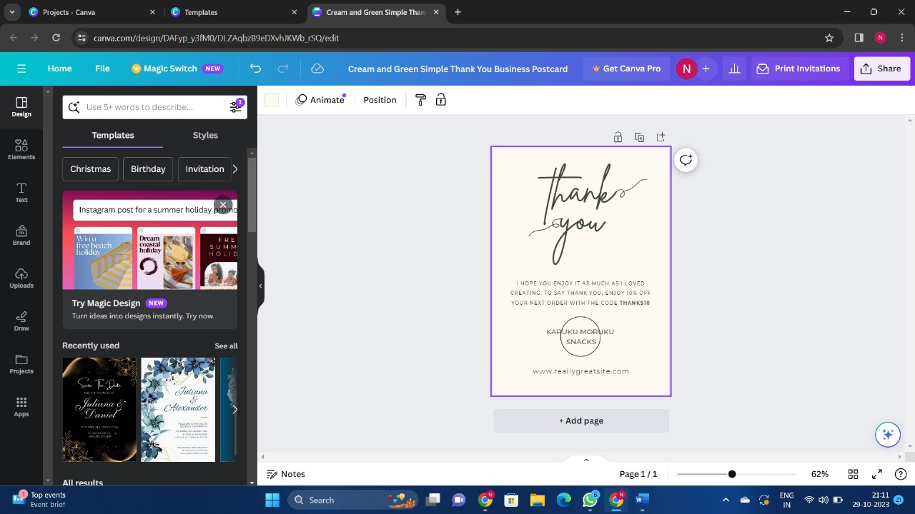

**Poster:**

